**IMPLEMENTATION OF CLOUD BURST PREDICTION SYSTEM**

**CONTENTS**

|  |  |  |
| --- | --- | --- |
| **S.No.** | **Table of Contents** | **Page No.** |
| **i.** | Introduction | 3 |
| **ii.** | Objective | 3 |
| **iii.** | Block Diagram | 4 - 7 |
| **iv.** | Methodology & Tools Used | 7 – 14 |
| **v.** | Advantages & Application | 15 |
| **vi.** | Major Problems | 15 |
| **vii.** | Future Scope | 16 |
| **viii.** | References & Related Research Paper | 17 - 18 |

**INTRODUCTION**

Cloud bursts are sudden and intense rainfall events that can cause catastrophic damage, particularly in hilly regions. The "Cloud Burst Prediction System" project is designed to predict these events using real-time data collection, deep learning algorithms, and hardware sensors. The system's primary goal is to provide timely alerts to authorities to minimize the impact of cloud bursts.

**OBJECTIVE**

To develop a system that accurately predicts cloud bursts using a combination of real-time data collection, deep learning algorithms, and hardware sensors. And deploy the model on a web platform for easy access and distribution of alerts.

Fig. 1 illustrates the overall flow of the System, showing the interaction between various components. Sensors at ground-level, weather stations collect real-time data (e.g., temperature, humidity, pressure). This data is processed through AI and deep learning models to predict cloud bursts. The results are then displayed and alerts are distributed via web or app interfaces, allowing authorities and users to take timely action.

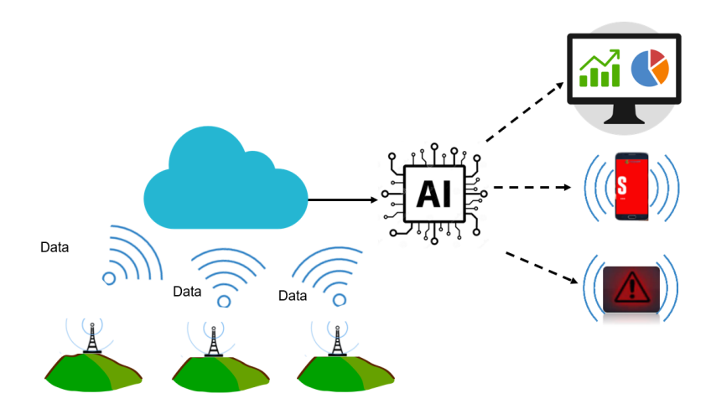

Figure 1: Schematic Overview & Outcomes of the System

**BLOCK DIAGRAM**

**Stage 1:** Fig. 2 demonstrates the stages involved in training and executing the deep learning model. The workflow starts with input data (historical and recent weather data), followed by Exploratory Data Analysis (EDA) and Feature Engineering. The processed data is then used to train a Time Series Model (using LSTM or RNN). Then, the model undergoes Hyperparameter Tuning, followed by Testing and Validation as a final model building stage. Once the model is trained, it is deployed for real-time prediction and alert generation.

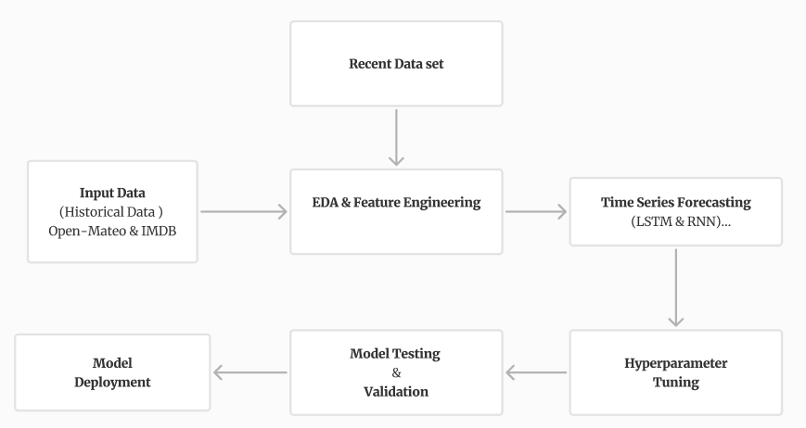

Figure 2: Block Diagram of Deep Learning Model Workflow

**Stage 2:** Fig. 3 depicts the hardware setup of the Cloud Burst Prediction System. The Arduino server (ESP32) is located at a central sensor station, communicating with multiple Arduino Nano units placed at remote weather stations. Each Arduino Nano is connected to sensors (e.g., temperature, humidity, pressure) and displays, gathering and displaying real-time data. The Arduino server then interacts with the main server via Ethernet or Wi-Fi modules to send the collected data for processing and predictions.

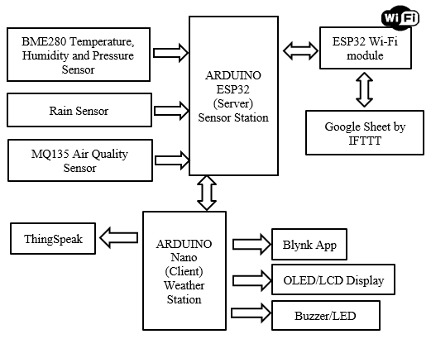

Figure 3: Arduino Server and Weather Station Setup

**Stage 3:** Fig. 4 represents the flow of interactions between the Arduino hardware, server, cloud database, and the AI model. The hardware devices collect and send real-time data to the server. The server, in turn, interacts with the cloud database to store and retrieve data for model predictions and further training. Then, the trained model uses this data to make updated predictions and a user interface (UI) interacts with the server to display real-time data and issue alerts based on predictions, ensuring that users are informed promptly.

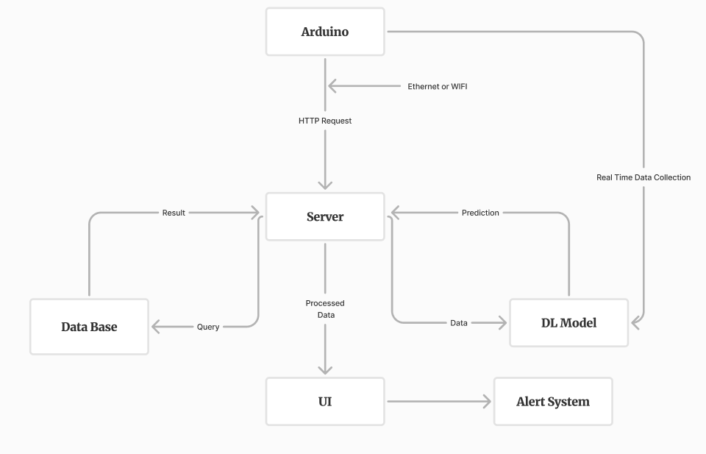 Figure 4: Server Interaction Flow in Cloud Burst Prediction System

**Circuit Diagram:**

This circuit diagram (Fig. 5) outlines the connections and flow within the Arduino-based weather stations. It shows how sensors (e.g., DHT22, BMP180) are connected to the Arduino Nano or ESP32 microcontrollers. The diagram also indicates the power supply connections and the communication modules (GSM, Wi-Fi, LoRa) that enable data transmission from the weather station to the central server. This setup ensures reliable data collection and transmission for real-time weather monitoring and prediction.

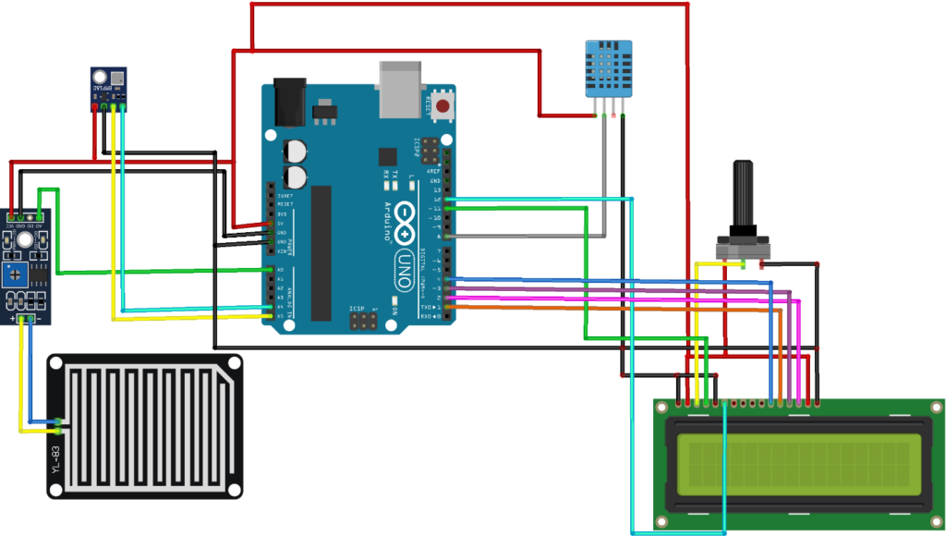

Figure 5: Arduino Circuit Flow for Weather Station

**METHODOLOGY & TOOLS USED**

**Data Collection:**

**Objective:**

The objective of the data collection phase is to gather accurate and comprehensive weather data from both remote sensors and official meteorological sources. This data serves as the foundation for the predictive models in the Cloud Burst Prediction System, ensuring that predictions are based on real-time and historical information. Effective data collection is crucial for timely and accurate prediction, allowing for appropriate alerts and preventive measures.

**Sources:**

To ensure the reliability and accuracy of the predictive models, data is sourced from both digital platforms and physical sensors. The combination of these sources provides a holistic view of the environmental conditions, improving the system's ability to forecast potential cloud bursts.

1. **Open-Mateo API:** This API provides real-time and historical weather data, offering a wide range of parameters such as temperature, humidity, and precipitation from various global locations.
2. **Indian Meteorological Department (IMD):** IMD offers precise and localized weather data for regions across India. It provides essential metrics like rainfall, temperature, and atmospheric pressure.

**Hardware Sensors:**

To capture real-time environmental data at ground level, various hardware sensors are deployed. These sensors are integrated into the system to continuously monitor weather parameters, providing essential inputs to the predictive models.

1. Temperature & Humidity Sensor (DHT22)
2. Barometric Pressure Sensor (BMP180)
3. LIDAR/Radar System
4. Rain Gauge
5. Wind Speed & Direction Sensor (Anemometer/Wind Vane)
6. Microcontroller: Arduino/Raspberry Pi
7. Communication Module: GSM/Wi-Fi/LoRa
8. Power Supply: Battery/Solar

Fig. 6 shows a screenshot of the Open-Meteo API data interface, highlighting the various weather parameters available through the API. The data includes real-time and historical information such as temperature, humidity, precipitation, wind speed, and atmospheric pressure from multiple global locations. This API serves as a crucial data source for the Cloud Burst Prediction System, providing reliable and up-to-date weather information that is essential for accurate predictions and timely alerts.

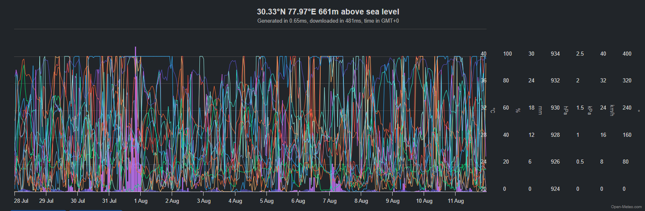 Figure 6: Screenshot of Open-Meteo API Data Interface

**Exploratory Data Analysis (EDA):**

**Objective:**

Exploratory Data Analysis (EDA) is a crucial step in understanding the underlying patterns, structures, and relationships within the collected meteorological data. For the Cloud Burst Prediction System, EDA helps identify the significant factors contributing to cloud bursts, such as temperature, humidity, atmospheric pressure, and rainfall. By visualizing these relationships, we can better understand the data and prepare it for the next steps in the model-building process.

**Tools:** Matplotlib, Seaborn, Ploty, etc.

**Approach:**

1. **Data Visualization:**
   * Use ‘Matplotlib’ and ‘Seaborn’ to create visual representations of the data, such as histograms, scatter plots, box plots, and heatmaps.
   * Generate time series plots to analyse the temporal trends in key variables like temperature, humidity, and rainfall.
   * Utilize ‘Plotly’ for interactive plots that allow deeper exploration of the data, such as 3D plots or animated visualizations to see changes over time.
2. **Correlation Analysis:** Apply heatmaps using ‘Seaborn’ to examine the correlation between different meteorological variables, identifying which factors are most strongly associated with cloud burst events.
3. **Outlier Detection:** Visualize data distributions to identify and analyse outliers that might represent unusual weather patterns or sensor errors.
4. **Feature Selection:** Identify the most relevant features for model training, using visual analysis to determine which variables contribute significantly to cloud bursts.

**Data Pre-processing:**

**Objective:**

Data pre-processing is essential for preparing the collected meteorological data for model training. In the Cloud Burst Prediction System, pre-processing ensures that the data is clean, consistent, and suitable for feeding into machine learning models. This step includes handling missing values, normalizing data, encoding categorical variables, and splitting the data into training and testing sets.

**Tools:** Pandas, NumPy, Scikit-learn (sklearn), etc.

**Approach:**

1. **Data Cleaning:**
   * Use ‘Pandas’ to handle missing data, either by imputing values or removing rows/columns with significant gaps.
   * Filter out erroneous or irrelevant data, such as sensor errors or irrelevant time periods.
2. **Normalization and Scaling:** Apply ‘NumPy’ and ‘scikit-learn’ to normalize the data, ensuring that all features contribute equally to the model. This is especially important for time series data, where variables may have different units and ranges.
3. **Encoding Categorical Variables:** Use ‘scikit-learn’ to convert categorical data (e.g., cloud types) into numerical values that can be processed by machine learning algorithms.
4. **Data Splitting:** Divide the dataset into training and testing subsets using ‘scikit-learn’, ensuring that the model is trained on one portion of the data and validated on another to prevent overfitting.
5. **Time Series Pre-processing:** For time series data, ensure that the data is properly formatted with time stamps and that any temporal dependencies are maintained during the splitting process.

**Time-Series Model Execution:**

**Objective:**

The execution of time series models is critical for accurately predicting cloud bursts, which are inherently temporal phenomena. The goal is to capture the complex patterns and dependencies in weather data over time, enabling the system to forecast abrupt cloud burst events with high precision.

**Deep Learning Algorithms:**

* **Long Short-Term Memory (LSTM):** A type of recurrent neural network (RNN) designed to learn from sequential data, particularly effective at capturing long-term dependencies in time series data.
* **Recurrent Neural Networks (RNN):** A class of neural networks designed for sequence modelling, where the output depends not only on the current input but also on previous inputs.

**Tools:** TensorFlow, PyTorch, Keras, MLFlow, etc.

**Approach:**

1. **Model Design:** Start by defining the LSTM or RNN architecture using **TensorFlow** or ‘PyTorch’. The model should be designed to handle sequences of meteorological data, with the ability to capture temporal dependencies.
2. **Training:** Train the model on historical weather data, utilizing ‘Keras’ for simplifying the model-building process and ‘MLFlow’ to track training experiments and model performance.
3. **Hyperparameter Tuning:** Use tools like scikit-learn’s GridSearchCV / RandomizedSearchCV or custom scripts to fine-tune hyperparameters, such as learning rate, batch size, and the number of layers.
4. **Evaluation:** Validate the model using test data and evaluate its performance using metrics like RMSE (Root Mean Square Error) or MAE (Mean Absolute Error). Use ‘MLFlow’ to log and compare different model versions.

**Model Deployment:**

**Objective:**

Deploying the trained cloud burst prediction model on a web platform is essential for making the predictions accessible to users and ensuring that alerts can be disseminated effectively. The deployment phase involves setting up a frontend for user interaction, a backend for processing requests, and hosting the application on a cloud platform.

**Technologies:** NextJS, Flask, AWS/GCP/Azure, etc.

**Approach:**

1. **Frontend:** Develop the UI using ‘NextJS’ along with ‘TaildwindCSS’ to create a responsive, easy-to-use application. Ensure that users can easily view predictions, historical data, and receive alerts.
2. **Backend:** Set up ‘Flask’ to create RESTful APIs that interact with the prediction model. The backend will handle incoming requests, process data, and return predictions to the frontend.
3. **Deployment:** Host the application on AWS, GCP, or Azure. Use services like ‘AWS EC2’ or ‘Azure App Service’ to deploy the backend and ‘AWS S3’ or ‘Azure Blob Storage’ for static frontend hosting. Ensure that the application is secured with HTTPS and is scalable to handle multiple users.
4. **Monitoring:** Implement logging and monitoring using cloud platform tools like ‘AWS CloudWatch’ or ‘GCP Stackdriver’ to track the application's performance and address issues promptly.

**Hardware Integration:**

**Objective:**

Integrating hardware components into the Cloud Burst Prediction System allows for the collection of real-time meteorological data, enhancing the model's accuracy and responsiveness.

**Components:**

* **Microcontroller:** Like Arduino/Raspberry Pi,used as the central processing unit for gathering data from sensors and sending it to the cloud or the local prediction system.
* **Sensors:**
  + **DHT22:** Measures temperature and humidity.
  + **BMP180:** Captures barometric pressure.
  + **LIDAR/Radar System:** Used for detecting cloud movement.
  + **Rain Gauge:** Measures precipitation levels.
  + **Anemometer/Wind Vane:** Monitors wind speed and direction.
* **Communication Modules:** Like GSM/Wi-Fi/LoRa, enables data transmission from the microcontroller to the cloud or a central server for processing.

**Approach:**

1. **Sensor Integration:** Connect sensors to the **Arduino/Raspberry Pi** to start collecting meteorological data. Each sensor will be programmed to send readings at regular intervals.
2. **Data Transmission:** Use **GSM**, **Wi-Fi**, or **LoRa** modules to transmit collected data to the central server or cloud platform, ensuring that the data is available in real time.
3. **Local Processing:** Perform basic data processing on the **Arduino/Raspberry Pi** to filter noise and prepare the data before sending it to the cloud.
4. **Power Supply System**

**Alert Mechanism:**

**Objective:**

The alert mechanism is designed to notify relevant authorities and stakeholders immediately when a cloud burst is predicted, allowing for quick response and mitigation efforts. The system must deliver these alerts through multiple communication channels to ensure they reach the intended recipients.

**Communication Channels:**

* **Web Notifications:** Real-time alerts delivered through the web application to logged-in users, including visual and audio signals for urgent notifications.
* **SMS Alerts:** Sent via the **GSM** module, providing direct and immediate notifications to mobile devices, especially useful for reaching users in remote areas.
* **Email Notifications:** Sent through the backend server (using services like **SMTP**) to provide detailed alerts to a broader audience, including government agencies and disaster management teams.

**Approach:**

1. **Notification System Setup:** Implement a notification system within the **Flask** backend that triggers alerts based on the prediction model's output.
2. **Web Notifications:** Integrate web push notifications into the **NextJS** frontend, ensuring users are notified in real time when a cloud burst is imminent.
3. **SMS Alerts:** Use the **GSM** module to send SMS alerts directly from the hardware setup, ensuring that key personnel receive immediate warnings.
4. **Email Notifications:** Configure the backend to send automated email alerts using SMTP services, providing detailed information about the predicted event, its location, and expected impact.

**ADVANTAGES & APPLICATIONS**

**Advantages:**

1. **Early Warning System:** Timely alerts to prevent or mitigate disaster impacts.
2. **Accuracy:** Combines deep learning and real-time data for precise predictions.
3. **Scalability:** Deployable in various regions with different climatic conditions.
4. **Integration:** Merges software and hardware for a comprehensive solution.

**Applications:**

1. **Disaster Management:** Supports timely evacuation and preparation to reduce disaster impact.
2. **Agriculture:** Aids in planning by predicting extreme weather.
3. **Urban Planning:** Provides data for infrastructure development in high-risk areas.

**MAJOR PROBLEMS**

1. **Real-Time Data Collection and Analysis:** Implementing a reliable system to collect and analyse meteorological data in real time, using hardware sensors and APIs.
2. **Climate Changes and Sudden Discrepancies:** Addressing the unpredictable nature of climate change and its impact on cloud formation, movement, and bursting.
3. **Abrupt Nature of Cloud Bursts:**

* **Challenge:** Cloud bursts often form, travel, and burst in minutes, making them difficult to predict. These events can also trigger heavy rainfall, floods, and landslides, leading to long-term damage.
* **Approach:** The system must account for the rapid development and movement of clouds, utilizing advanced algorithms and real-time data to predict such events accurately.

**FUTURE SCOPE**

**Remote Sensing and Satellite Imagery:** Satellite imagery provides high-resolution satellite data which gives detailed spatial data that can be used to track cloud formation, movement, and other critical atmospheric conditions in real time.

**Approach:**

1. **Data Integration:** Incorporate satellite data into the existing dataset, using APIs from satellite providers (e.g., NASA or ESA) to access real-time imagery and weather data.
2. **Model Enhancement:** Use the high-resolution spatial data to refine the prediction model, improving its ability to detect and predict cloud burst events with greater accuracy.
3. **Advanced Visualization:** Utilize tools within the UI like ‘ShadCN’ to visualize satellite imagery alongside prediction data, giving users a more comprehensive view of potential cloud burst events.
4. **Collaboration with Meteorological Agencies:** Partner with organizations like the IMD or international meteorological agencies to access more sophisticated satellite data and integrate it into the cloud burst prediction system.

**REFERENCES & RESEARCH PAPERS**

References:

**Links:**

* **Wikipedia Contributors:** Weather forecasting - Modern methods. Wikipedia: [https://en.wikipedia.org/wiki/Weather_forecasting#Modern_method](https://en.wikipedia.org/wiki/Weather_forecasting%23Modern_method)
* <https://static1.squarespace.com/static/55774404e4b07f2c7dc881a0/t/5ec6c219b10cc30d341f7c8b/1590084123960/Modeling+Clouds+and+Wind.pdf>
* **Open-Mateo API:** <https://open-meteo.com/>

**Image Resources:**

* Circuit diagram: <https://techieyantechnologies.com/a-smart-weather-forecasting-system/>
* Arduino Block Diagram: <https://www.researchgate.net/figure/Project-block-diagram_fig1_345327830>
* Objective: <https://www.ijrti.org/papers/IJRTI2206303.pdf>

**Hardware Resources:**

* <https://techieyantechnologies.com/a-smart-weather-forecasting-system/>
* <https://docs.arduino.cc/hardware/uno-rev3/>

Related Research Papers:

1. **Arduino, G., Reggiani, P., & Todini, E.** (2005). Recent advances in flood forecasting and flood risk assessment. *Hydrology and Earth System Sciences*, 9(4), 280–284.
2. **Srinivasan, J.** (2013). Predicting and managing extreme rainfall. *Current Science*, 105(1), 7–8.
3. **India Meteorological Department (IMD).** (2013). A preliminary report on heavy rainfall over Uttarakhand during 16–18 June 2013. *India Meteorological Department, Ministry of Earth Sciences*.
4. **Ganguly, A. R., & Teinhaeuser, K.** (2008). Data Mining for Climate Change and Impacts. *IEEE International Conference on Data Mining*.
5. **Badhiye, S. S., Wakode, B. V., & Chatur, P. N.** (2012). Analysis of Temperature and Humidity Data for Future Value Prediction. *International Journal of Computer Science and Information Technologies (IJCSIT)*, 3(1).
6. **Dabhi, V. K., & Chaudhary, S.** (2014). Hybrid Wavelet-Postfix-GP Model for Rainfall Prediction of Anand Region of India. *Advances in Artificial Intelligence*, 1-11.
7. **Saikia, P., & Tahbilder, H.** Prediction of Rainfall Using Data Mining Technique Over Assam. *Indian Journal of Computer Science and Engineering (IJCSE)*.
8. **National Remote Sensing Centre, Indian Space Research Organisation.** (n.d.). Hydrological and Hydraulic Simulation Study of Kedarnath Flash Floods.
9. **Thayyen, R. J., Dimri, A. P., Kumar, P., & Agnihotri, G.** (2013). Study of cloudburst and flash floods around Leh, India, during August 4-6, 2010. *Natural Hazards*, 65, 2175–2204. doi:10.1007/s11069-012-0464-2.
10. **Ramakrishnan, P. S., Purohit, A. N., Saxena, K. G., & Rao, K. S.** (1994). *Himalayan Environment and Sustainable Development*. Indian National Science Academy, New Delhi.
11. **Dutta, P. S., & Tahbilder, H.** Prediction of Rainfall Using Data Mining Technique Over Assam. *Indian Journal of Computer Science and Engineering (IJCSE)*.
12. **National Conference on Advancements in Computer Science and Engineering.** (2020). Rainstorm Prediction System. *International Journal of Scientific Research in Science, Engineering, and Technology (IJSRSET)*.
13. **Pabreja, K.** (2012). Clustering Technique to Interpret Numerical Weather Prediction Output Products for Forecast of Cloudburst. *International Journal of Computer Science and Information Technologies (IJCSIT)*, 3(1), 2996-2999.
14. **Sunil, A., Binny, B. A., Benny, J., Rajeev, R., & Manuel, A.** (2020). Predister: An Intelligent Device to Predict Cloud Burst. *International Journal for Research Trends and Innovation (IJRTI)*, 7(6). ISSN: 2456-3315.
15. **Young, M.** (1989). *The Technical Writer’s Handbook*. University Science.